Lab: JavaScript Fundamentals
You can check your solutions in https://judge.softuni.org/Contests/5401/JavaScript-Fundamentals-Lab

Substring
Write a function that receives a string and two numbers. The numbers will be a starting index and count of elements to substring. Print the result.

Input / Output
Input | Output
'ASentence', 1, 8 | Sentence
'SkipWord', 4, 7 | Word

Hints
Create a new string that takes the needed count of elements from the given string.
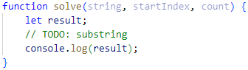

Censored Words
Write a function that receives a text as a first parameter and a single word as a second. Find all occurrences of that word in the text and replace them with the corresponding count of '*'.

Input / Output
Input | Output
'A small sentence with some words', 'small' | A ***** sentence with some words
'Find the hidden word', 'hidden' | Find the ****** word

Hints
Save the new text in a new variable.
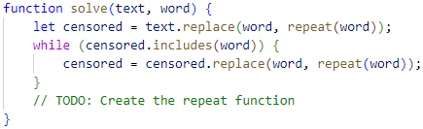
The repeat() function should take the length of the word and return that count of stars '*'.

Count String Occurrences
Write a function that receives a text and a single word that you need to search. Print the number of all occurrences of this word in the text.

Input / Output
Input | Output
'This is a word and it also is a sentence',  'is' | 2
'softuni is great place for learning new programming languages',  'softuni' | 1

Hints
Split the sentence into words and create a counter that stores how many times the searched word occurs.
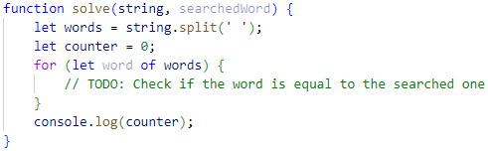

Format Grade
Write a function that receives a grade between 2.00 and 6.00 and prints a formatted line with grade and description.
- < 3.00 - "Fail"
- >= 3.00 and < 3.50 - "Poor"
- >= 3.50 and < 4.50 - "Good"
- >= 4.50 and < 5.50 - "Very good"
- >= 5.50 - "Excellent"

Examples
Input | Output
3.33 | Poor (3.33)
4.50 | Very good (4.50)
2.99 | Fail (2)

Hints
Use a series of if statements checking the threshold between grade brackets
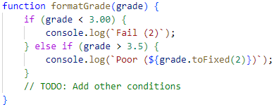

Math Power
Write a function that calculates and print the value of a number raised to a given power:

Examples
Input | Output
2,8 | 256
3,4 | 81

Hints
Create a function that will have two parameters - the number and the power.
Print the result to the console.

Repeat String
Write a function that receives a string and a repeat count n. The function should return a new string (the old one repeated n times).

Examples
Input | Output
"abc", 3 | abcabcabc
"String", 2 | StringString

Hints
Use a loop or another method to repeat the input string.
Use the return operator to produce the result.

Orders
Write a function that calculates the total price of an order and prints it on the console. The function should receive one of the following products: coffee, coke, water, snacks; and a quantity of the product. The prices for a single piece of each product are:
- coffee – 1.50
- water – 1.00
- coke – 1.40
- snacks – 2.00
Print the result formatted to the second decimal place.

Example
Input | Output
"water", 5 | 5.00
"coffee", 2 | 3.00

Hints
Create a function and pass the two variables to it.
Print the result in the function.

Hints
Use a switch statement for the different operators.

Person Info
Write a function that receives 3 parameters, sets them to an object, and returns that object.
The input comes as 3 separate strings in the following order: firstName, lastName, age.

Examples
Input | Object Properties
"Peter",  "Pan",  "20" | firstName: Peter  lastName: Pan  age: 20
"George",  "Smith",  "18" | firstName: George  lastName: Smith  age: 18

Hints
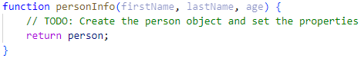

City
Write a function that receives a single parameter – an object, containing five properties:
{ name, area, population, country, postcode }
Loop through all the keys and print them with their values in format: "{key} -> {value}"
See the examples below.

Examples
Input | Output
{  name: "Sofia",  area: 492,  population: 1238438,  country: "Bulgaria",  postCode: "1000"  } | name -> Sofia  area -> 492  population -> 1238438  country -> Bulgaria  postCode -> 1000
{  name: "Plovdiv",  area: 389,  population: 1162358,  country: "Bulgaria",  postCode: "4000"  } | name -> Plovdiv  area -> 389  population -> 1162358  country -> Bulgaria  postCode -> 4000

Phone Book
Write a function that stores information about a person's name and phone number. The input is an array of strings with space-separated name and number. Replace duplicate names. Print the result as shown.

Example
Input | Output
['Tim 0834212554',  'Peter 0877547887',  'Bill 0896543112',  'Tim 0876566344'] | Tim -> 0876566344  Peter -> 0877547887  Bill -> 0896543112
['George 0552554',  'Peter 087587',  'George 0453112',  'Bill 0845344'] | George -> 0453112  Peter -> 087587  Bill -> 0845344

